Lab 1: Paper Copy

EE107-01

Talen Phillips

Dustin Maclay

/\* Lab1: First Program \*/

#include <stdio.h>

int main (void)

{

printf("I like EE 107. |Maybe I don\'t. |\nAm I talking to |myself again? 6655|\nOK -2.4 |abc a232|\n");

return 0;

}

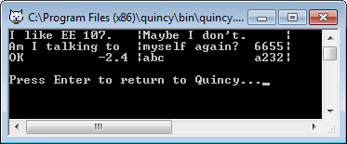

/\* Lab1: Second Program \*/

#include <stdio.h>

int main (void)

{

printf("1\t2\t3\n9\t\b10\t\b11\n99\t\b\b100\t\b\b101\n12121212121212121\n");

return 0;

}

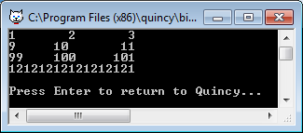

/\* Lab1: Third Program \*/

#include <stdio.h>

int main (void)

{

printf(" \*\n \*\*\n \*\*\*\n \*\*\*\*\n\*\*\*\*\*\n\n \*\n \* \*\n \* Z \*\n \*\*\*\*\*\*\*\n\n %%\n %%\"\n %%\"\\n\n");

return 0;

}

